**Power Bank Chain**

*--Decentralized and Valuable Credit Data Platform for supervising the powerbank economy*

**1. Program Overview**

Based on the sharing economy, Power Bank Chain is a smart, reliable, and valuable platform which enables all the power bank companies to provide their service to all the individual users. As an underlying technical support, blockchain is of significance to the success of this platform. As blockchain technology subverts the existing centralized credit platform, Power Bank Chain is designed to achieve value quantification and circulation on the platform by using the Power Bank Coin, briefly called "PBC". This Power Bank Chain aims to build a reliable credit system, in which the data is real and unique, to create a reliable power bank economy, and to pursue the great vision of “ interconnected credit and sharing future”.

*Keywords: Power Bank Chain, Credit data platform, Power bank sharing economy, Value quantification, circulation on the platform , Power Bank Coin*

**2. Program Goal**

Our goal is to protect Customers and power bank sharing companies’ interests. Same as other sharing economy problems, power bank sharing companies also face the same problems like other sharing company that the power banks may be lost or damaged. In order to reduce the damage rate, companies need a credit system to accurately determine the price that they need to charge the customers with different credit. They can easily do that by searching the transaction record of customers from our platform. Of course, they need to pay a little token for this service. For those who don’t have enough records, for example, new customers, they will need to have enough token as deposit. Once breaching of contract happens, our platform will give a third-party oracle based on the record we have. For customers, our platform can provide evidence to help them protect their own interests. From these two perspectives, Power Bank Chain will ensure the interests of both companies and customers.

*Keywords: company’s interest, damage rate, deposit, third party-oracle*

**3. Introduction on Power Bank Sharing Economy**

Power bank sharing is a kind of sharing economy products. Sharing economy means on the same ownership premise, benefits will be gained by temporarily transferring usage rights and increasing the utilization rate of resources. In Power bank sharing economy, customers only need a small amount of money to borrow power banks. Traditionally, customers need to pay deposit for using the power banks in case they don’t return or damage power banks. Once power banks have been returned successfully, the deposit will be returned to the customers. However, with our platform, customers can pay less deposit, sometimes even no deposit, based on their credit records.

*Keywords: Sharing economy, deposit, credit*

**4. Current Situation Analysis of Power Bank Sharing Economy**

* Environment: The sharing economy is the future tendency, but some useful sharing products are not available yet. For example, the power bank sharing, is one of those indispensable product. Especially nowadays the physical limits of smartphone battery which influence the pace of the smartphone development. We can see the line chart in image-1. And also more than half numbers of people nowadays charge more than one time per day which we can see from the 2017 distribution of charging times for portable devices, image-2. Therefore, the development of the power bank sharing economy is promising.
* User information: While the power bank sharing penetrates into the personal sector, enterprises find it difficult to know the user information. The cost of large amounts of information screening is enormous. With a single data acquisition channel, personal credit for each user can not be judged by traditional sharing enterprises and different permissions for different users are also impossible, which lead to significant increasing costs of product supervision and operation.
* Interoperable: Although powerbank-sharing enterprises record the user data in the APP, the new user's comprehensive credit level can not be judged. The enterprise databases are not interoperable in the traditional Internet domain to ensure information safety, which leads to repeated collection of the user data by different sharing enterprises.

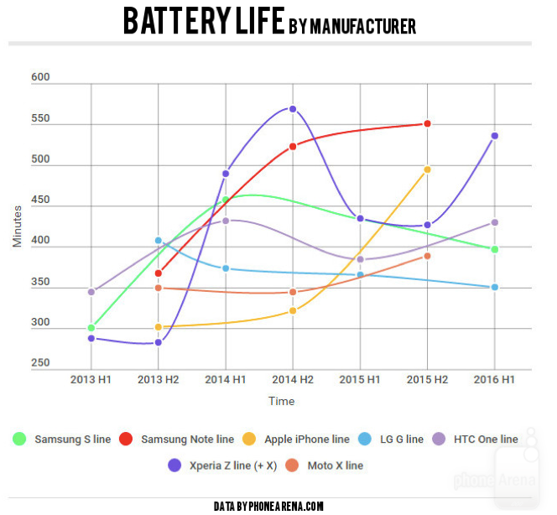

*Image-1: Battery Life by Manufacturer*

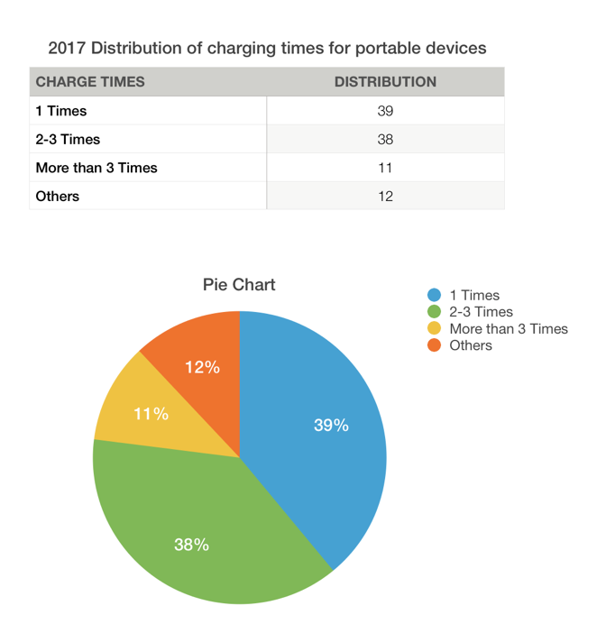

*Image-2: Distribution of Charging Times for Portable Devices*

**5. Introduction on Power Bank Chain**

Our platform is an easy way to fix the trust problem between the companies and customers. For customers, we keep track and record the performance of the company, eliminate the possibility that the company may delete or distort the data and our platform provide a place for customers to protect their own rights and interests. The most important thing is they can get the feedback efficiently from the platform. Customers will have enough information with credibility provided by blockchain to help them make the best choice.

For company, they do not need cost much money and time to root causes, all the data are trackable in our system, also they don’t need to pay much money to establish their own credit system. On the other hand, this will protect the privacy of consumers and avoid disputes that they may infringe consumer privacy. Some companies even need to supervise staffs. But now they don’t need to cost a lot on that. Our system can help them to regulate employee performance and behavior.

Overall, our platform can improve the share-economy system, no matter from business and technology. Our first step is implementing the data recording with blockchain technology, then we will try to launch our platform, the last step is issuing our own token. Preliminary, our token will be used like procedures fee. For example, companies need to pay fee for confirming the transaction record. Our token is not like bitcoin. It is more like ripple. We will use our token like a reward for those people who help to build and maintain the community.

*Keywords: trust problem, credit records, transaction records, ripple*

**5.1 Power Bank Value Statements**

* Users: To get a preferable price for the service, contribute to the power bank sharing system to get rewards, without privacy or data disclosure.
* Power bank companies: To capture high-quality data reports, optimize program at lower cost, and increase profits.
* Power Bank Chain platform: To provide APP for companies and individuals, obtain real credit index from users, and achieve a win-win economy for both companies and individuals.

**5.2 Decentralized Sharing Ecology of Power Bank Chain**

The feature of blockchain is that once the data has been uploaded on the chain, the data is open, transparent, and can not be changed. The data credibility is ensured.

The PowerBankChain will store three types of data on the chain:

* user information in the APP;
* PBC transaction information;
* participant's digital information on Power Bank Chain.

**5.3 Smart Contract of Power Bank Chain**

The user chooses the relevant conditions to generate the smart contract, such as the lease time, the payment of the deposit, the rent and the deductible, etc.. When the smart contract obtains external data, detected in line with the preparatory conditions, will take the initiative to replace the enterprise and users to respond, such as automatic delivery, automatic refund, automatic payment and so on. The whole process is recorded in the blockchain, to ensure that all states of correctness, integrity and non-tampering, and to reduce the impact of accidents.

**5.4 The mechanism of our Power Bank Chain**

The mechanism of the system is illustrated in the Image-3. The state change will be documented on our Powerbank Chain.

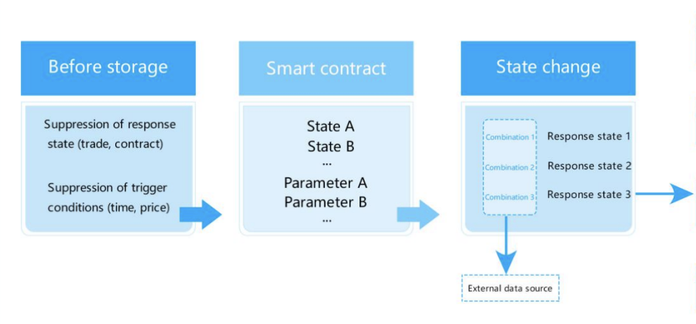

*Image-3: Mechanism of Power Bank Chain*

**6. Operational Mechanism of Power Bank Chain**

**6.1 Business Role Statement**

* APP users: They can enjoy preferential price when they using the APP. Moreover, they can also contribute to the APP.
* Power bank sharing companies: Power bank sharing companies can use our platform to provide power bank sharing service for users, initiate a rewarding system to attract new users, using PBC as reward.
* Power Bank Chain platform: It provide the platform for the companies to run their power bank sharing products through APP. This APP serves as a platform of credit disclosure for both companies and individual users in the two sides of the transactions. Meanwhile, it issues PBC with the initial aim to acquire new users and the ultimate goal to make PBC more valuable.

**6.2 Operational Mechanism**

* The final target audiences of our platform is not only power banks sharing business, but also include other shared economy, such as sharing bicycle and sharing room. We accept the access of different enterprises by opening API interface. Provide services for them, and further integrate a number of the resources of sharing enterprises through data sharing, resources exchange, and win-win cooperation to build a more valuable and competitive share industry ecosphere.
* Accept the APP and FB, Google official account access of the sharing enterprise by opening api interface to upload the enterprise database information, the user using data and valuable contents.
* Release the smart contracts, carry out the data analysis of contract execute and automatic ledger, record and search incentive policy information and key data in the chain, transfer transaction of PBC to achieve open and transparent account management information management, and enhance the credibility of the industry.

**6.3 Value Distributiuon**

The power charging is of significance for the mobile devices, especially in a situation where no charger is available. Also, it is inconvenient for people to carry the power bank with them every day. Thus, the existence of the power bank sharing is very useful.

It is a common problem for the whole sharing economy that the operational difficulty always prevent the product providers from providing the service, like the sharing bicycle. However, compared with other sharing products, the power bank sharing system is much easier to operate, monitor and maintain, given the device is more portable and of less value than other sharing products. Overall, this power bank sharing is highly needed and can be easily maintained, which stand as solid reasons to run the business.

The value of each role in the PowerBank Chain and the benefits obtained are described as below:

* APPs’ users

Value creation: Bring information value to the Powerbank-sharing enterprise chain through the use of shared applications.

Profit yielding: Users use shared software to get PBS as an incentive. The Powerbank Chain accurately analyze the information of the share enterprise so as to bring a better application experience for users

* Sharing enterprises

Value creation: Provide shared services and upload accurate use reports for application users, to enhance the software user experience more effectively.

Profit yielding: When a user uses a sharing product through a sharing enterprise app/FB/Google official account, or when the product has been used for some time and has use value, the automatic ledger of smart contracts will be triggered. The corresponding proportional PBS as an incentive will be distributed to the user by Powerbank Chain. Sharing enterprises can exchange PBS using software add-on services, and the Powerbank Chain will buy back according to PBS and the user information of PBS..

**6.4 Advantage Analysis of the Ecological Construction**

Powerbank Chain user encryption information, smart contract, PBC incentive strategy, key business data, transfer transaction information etc., circulating in the in the system will be recorded in the blockchain network. Based on the open, transparent, tamper-resistant blockchain, the data mentioned above is transparent and reliable. Encryption is used for sensitive data, taking privacy protection into account. The Powerbank Chain system based on trusted data flow provides the traditional sharing enterprise with the opportunity to share the resources of the industry. The different powerbank sharing enterprises participating in the Powerbank Chain, forming an ecosystem, will benefit from two aspects:

* Get more user resources for powerbank shared applications;
* Cooperate with the sharing enterprises in the industry, which can not be accomplished before. All powerbank sharing enterprises in the Powerbank Chain, enter the market as a whole. Through the cooperation and advantages complementary to each other in this industry, a wider range of market value will be gained, so that the powerbank sharing economy contributes to the society in a larger scale.

**7. Power-Bank-Chain’s Key Strength - Solving the Credit Issue**

* Considering that the transaction is based on the Internet or mobile Internet, two sharing parties can not check mutual information, and sharing becomes risking in some cases that they are completely unfamiliar with each other. And then the access to the PowerBank Chain make the transactions more smooth and secure, due to the uniqueness of real name, and open transparent principles. The entire transaction can be traced to the source, so as to ensure the interests of both parties.
* In most cases, when the interests of the platform is reduced or removed, the platform is able to tamper with the data through the backstage, and the data will never be retrieved or investigated. At this moment the access to Powerbank Chain can better control the corporate credit. Due to consensus mechanism and tamper-resistant principle, the entire transaction data can not be tampered on the platform, making the platform data more credible and more valuable.
* More efficient user experience As traditional sharing applications, when new users register, their ratings are raised at the initial level. In this mode, high-quality user with high-credit groups can not get the best quality user experience at the first time and the user's first impression of the software is affected. Through data sharing mechanism in the sharing ecosystem,each power bank-sharing enterprise in the PowerBank Sharing can get the most authentic user credit data, and the user's real rating can be adjusted in time based on obtained information. High credit user groups can get the most out of the user experience in new sharing apps at the first time.

**8. Power Bank Coin (PBC)**

**8.1 The Role of PBC**

PBC is the token of the system. Besides the application of PBC in the above mentioned smart contract execute, it can be used in related services include but are not limited to the following scenarios:

* Powerbank Share application user incentives
* Powerbank Share application platform transaction services
* PowerBank Chain underlying data consumption
* PowerBank Chain smart contract consumption In addition, the PowerBank Chain will continue to expand the use of PBC scenarios, while continuing to allow more third parties to access to PowerBank Chain to add PBC value.

**8.2 The Value of PBC**

PBC is the basis for the entire power bank-sharing system. While power bank-sharing system provides external services, it receive a certain number of PBC as a supplement. PBC consumption, exchange and other circulation can be done by the users who have access to Dapp. Dapp Users gaining more benefits and added values through PBC consumption, or third party of Dapp using credit data by consuming PBC, maintain or boost PBC price. Users can also share items and recommend friends to join in to gain PBC, so as to propel more users to join Dapp to share items, with increasing Dapp users and greater growth space. In consequence, the price of PBC will be increased. Similarly when people use Bitcoin for exchange, it is necessary for them to go to the market to buy Bitcoin. With the increasing number of people use Bitcoin for exchange, Bitcoin will be appreciated. The PowerBank Chain system helps the zero-rent platform to better serve the user while also providing it to other third parties to share applications. In theory, the prevalent global sharing economy now brings rapidly growing users and increasing awareness of PBC. With the explosive growth of the shared application, PBC value will be increased quickly.

**9. Trategy of the Initial System Test**

**9.1 PBC policy**

* PBC allocation scheme Total: 10 billion

PBC Public issuance this time: 4 billion PBC

Early investors: 1 billion PBC

Foundation management: 5 billion PBC

* PBC release plan

1)Accepted currency: Bitcoin (BTC), Ether (ETH)

2) Direct issue: 4 billion PBC

3) ETH and BTC collected at the end of crowdfunding are managed by the

Foundation's account;

4) Deblocking PBS collected by investors includes 4 cycles. The length of a cycle is

30 days and 1/4 the total stock of PBS is deblocked each time.

* Use of funds:

1) Technology development: 23%

2) Community maintenance: 15%

3) Commercial operations: 10%

4) Law and Compliance: 2%

5) Reserves: 50%

**9.2 Powerbank Chain status and vision**

* The status of Powerbank Chain

In February, Planned to build Powerbank Chain;

In March, the development of Powerbank Chain cold wallet and blockchain browser were completed

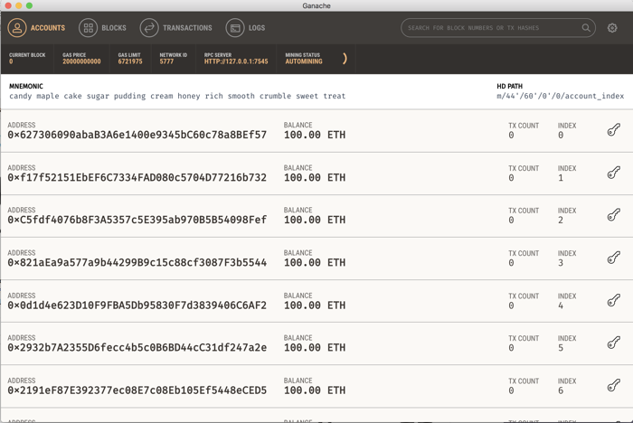

*Image-4: Application Interface*

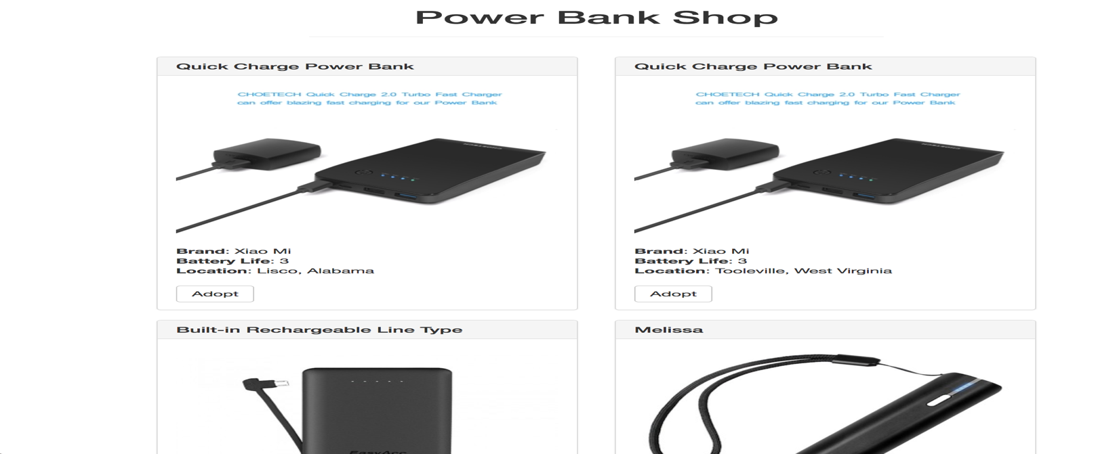

*Image-5: Power Bank Shop Website*

* The vision of Powerbank Chain

In April, FB/Google official account, official website and online wallet release

In June, the ealry investment was launched officially by Powerbank Chain

In August, Powerbank Chain with open and shared applications circulated, and strategic cooperation was reached with the shared enterprise to promote the ShareChain and expand the user groups.

In 2018, Powerbank Chain will access to 10-20 powerbank shared applications

In 2019, Powerbank Chain will access to 50+ shared applications ( including shared bicycles, shared travel, shared room, shared clothing, etc.)